**OMIS 340 HOMEWORK 2. INVENTOY MEASURES ANALYSIS**

* You are now ready to manipulate and visualize there data. Several charting options are available – bars, lines, pies, scatter/bubble, etc.
* Please use the appropriate charting techniques, answer the following questions. (Any chart will be fine if you find the answer for each question)
* Be sure to save each chart. Remember, you can do that by clicking on the plus sign at the bottom of the vitalize page.
* Add your name initial to the title of each chart. Without it, we can’t give you any point.
* Provide your answer and interpretation for each chart to get full credits in this Word document.

**##### Data Analysis for Supply Chain Performance**

1. Open OMIS 340 *Compustat Data Homework 2 Spring.xlsx file.* **Compute the average aggregate inventory value (INVsum), weeks of supply, and INV turnover properly. Save the change.**
2. Launch **SAP Predictive Analytics**
3. Click **Expert Analytics (left) 🡪 Expert Analytics** (right)
4. From the menu, choose **File 🡪 New**
5. In the Add new dataset window, choose **Microsoft** **Excel**. **Next**.
6. Browse for the OMIS 340 *Compustat Data Homework 2 Spring.xlsx* file. (Locate this file on your computer.)
7. Check to see if 72 rows of data have been acquired. **Create**.
8. Go to the **Visualization** panel**.**

**Question 1** (Point 20): Display the trend of gross profit over years for each company within the same chart. Which company shows the highest profit in general?

Johnson and John generally have the highest profit

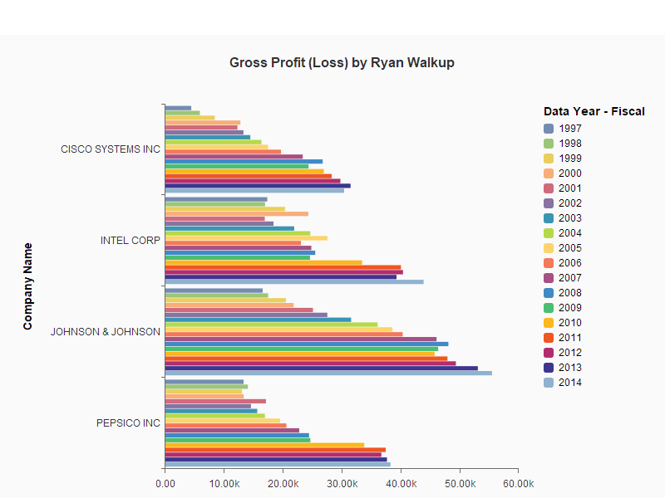

**Question 2** (Point 20): Display the trend of cost of goods sold over years for each company within the same chart. Which company shows the highest cost of goods sold in general?

In general Pepsico has the highest cost of goods sold

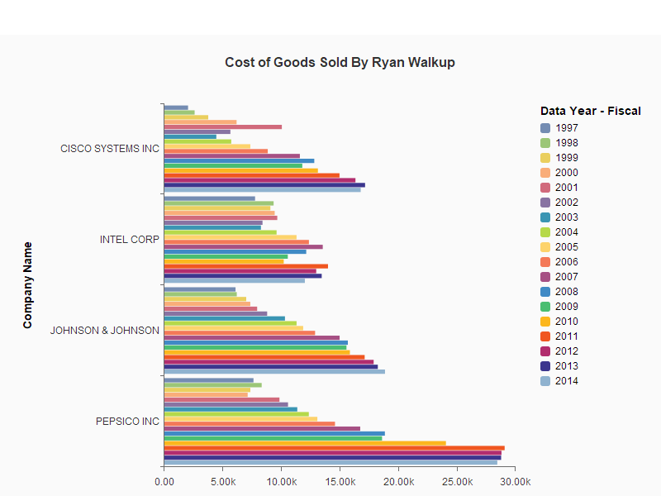

**Question 3** (Point 20): Which company does have the highest amount of aggregated inventory asset over years?

Hint: Use a *Stacked Column* chart. Y-axis: *INVsum*, X-axis: *Data Year*, Legen Color: *Company Name*.

Johnson & Johnson has the highest amount of aggregated Inventory asset.

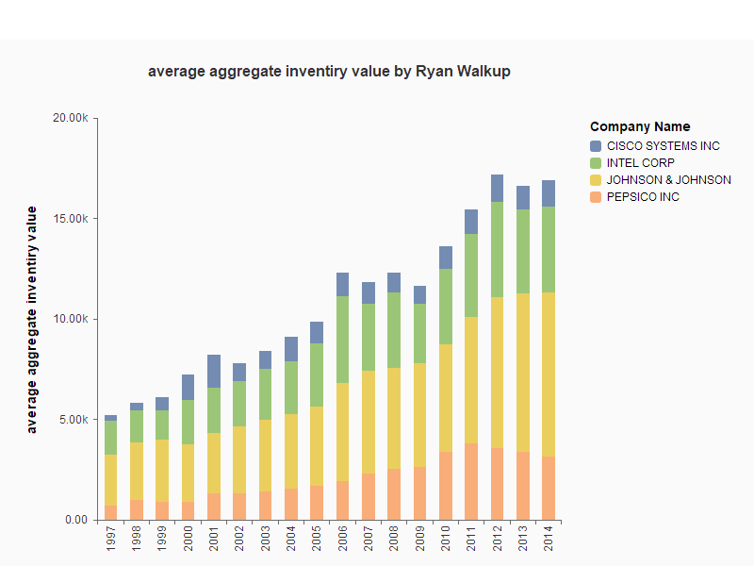

**Question 4** (Point 20): Compare their inventory turnover performance over years. Which company does seem to improve its flow of materials and information?

Cisco Systems has the highest inventory turnover of the four companies.

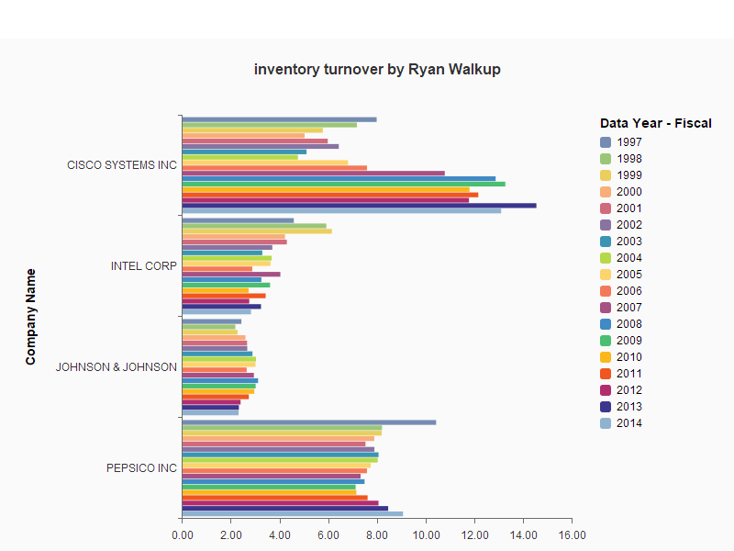

**Question 5** (Point 20): Compare their weeks of supply performance over years. Which company does seem to hold its inventory for the longest time?

Johnson and Johnson have the highest weeks of supply.

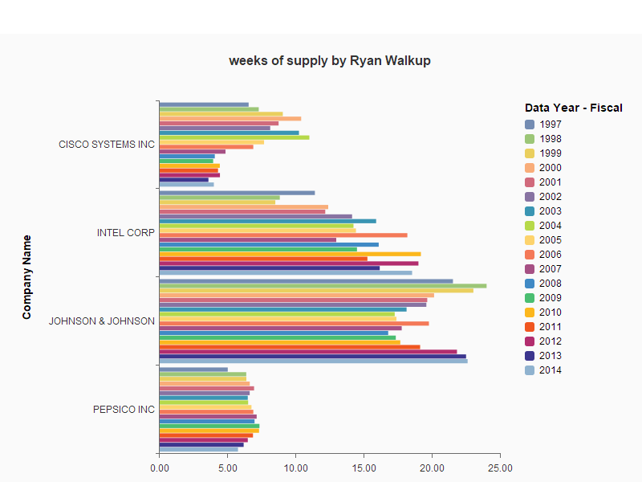

**\*\*\* One more time, check if you put your initial to the title of each chart. A violation of this requirement will yield 0 points for your homework. \*\*\***